# Unit 7 – Lesson 3. Order of Finite Markov Chain and Dishonest Casino

***Aim:*** What is the order of Markov Chain? What is a hidden Markov Chain?

**Objectives:** After the lesson, students should be able to:

* Obtain understanding of Markov property and Markov chain
* Explain Markov chain using examples

***References:***

* Unity 5.x Game AI Programming Cookbook, Palacios
* Duke University, Introduction to Machine Learning, Markov Chain
* CMU, Machine Learning
* Other wonderful online images and simple examples

**CLASS PROCEDURE:**

***Do Now:***  Suppose tomorrow’s weather depends on today’s weather only. Given today is sunny and the finite state diagram below, what is the probability that the coming days are sunny, rainy, cloudy, cloudy, sunny?

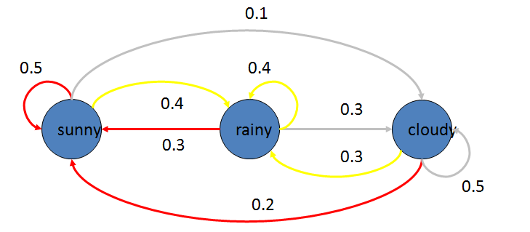

***Class Discussion / Presentation:***

1. What is an Order – 1 Markov Chain?

* We call it an Order-1 Markov Chain, as the transition function depends on the current state only.

1. What is the Order – n Markov Chain?

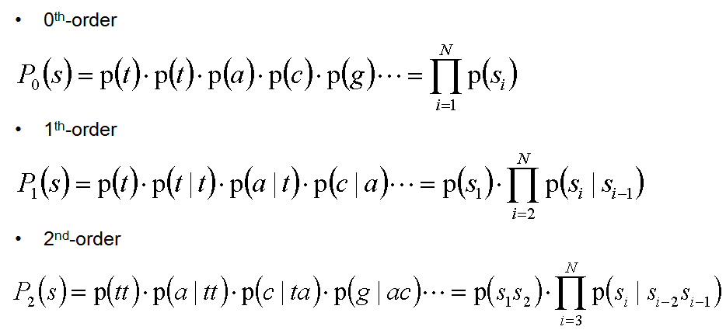

1. In the “Do Now”, given today is sunny, what is the probability that it will be rainy 4 days later? Use the transition matrix to solve the problem.

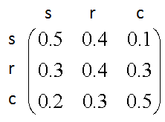

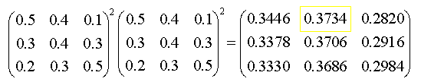

1. What is the probability that it will be rainy 20 years later? How do we solve the problem?
2. What is Limiting probability?
   * We call it the “Limiting probability” when the machine becomes steady.
   * We do not care the “start state” as it brings little effect when there are infinite number of states.
3. In the example of the “Do Now”,

* Since the start state is “don’t care”, instead of forming a 2-D matrix, the limiting probability is express a single row matrix:



* Since the machine is steady, the limiting probability does not change even it goes one more step. Then we have:

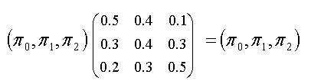

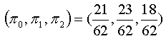

***Class Discussion / Pair – sharing Activity: The Dishonest Casino***



A casino has two dices:

**Fair dice:**

**P(1) = P(2) = P(3) = P(4) = P(5) = P(6) = 1/6**

**Loaded dice:**

**P(1) = P(2) = P(3) = P(4) = P(5) = 1/10**

**P(6) = ½**

Casino player switches back and forth between fair and loaded die with **5%** probability.

